**A PROJECT REPORT**

**ON**

**“Word Dictionary”**

SUBMITTED TO

BHAVAN’S SHREE H.J. DOSHI INFOTMATION

TECHNOLOGY INSTITUTE,

JAMNAGAR

**AFFILICATED TO**

**SAURASHTRA UNIVERSITY, RAJKOT**



**FOR THE COURSE OF**

**BACHELOR OF COMPUTER APPLICATION**

**(5th SEM)**

**SUBMITTED BY:**

**Parasramani poonam**

**UNDER THE GUIDENCE OF**

**HASIT SIR**



**INDEX**

|  |  |
| --- | --- |
| **No** | **Title** |
| 1. | Introduction |
| 2. | Scope |
| 3. | Tools used |
| 4. | Data Dictionary |
| 5. | Data Flow Diagram |
| 6. | Forms Layout (Screenshots) |
| 7. | Limitations and Future Enhancements |
| 8. | Bibliography |

**[1] INTRODUCTION**

**Project Title:**

Word Dictionary

**Project Type:**

Windows Application

**Front End:**

C#.NET

**Back End:**

XML

**Project Duration:**

3 Months

**Developed By:**

Paraasramani poonam

**Guidance by:**

Lect. Hasit chandrana

**Submitted To:**

BHAVAN’S SHREE H.J. DOSHI INFOTECH

**[2] SCOPE**

This is windows base application.

This application used to Find Word meanings,verbs and adverb.

The scope of this system is to provide user efficient working environment and more output can be generated through this. This system provides user friendly interface resulting in knowing each and every usability features of the system.

**[3] Tools Used**

**1)Front End :** C#.NET

**2)Back End :** XML

**3)IDE :** Visual Studio

**[4] Data Dictionary**

**1) Login**

<?xml version="1.0" encoding="UTF-8"?>

<Users>

<User>

<Username></Username>

<Password></Password>

<Date></Date>

<Time></Time>

</User>

**2) Synonyms_data**

<?xml version="1.0" standalone="yes"?>

<Words>

<Word>

<Word-Text></Word-Text>

<Synonyms></Synonyms>

</Word>

**3) Verb_data**

<?xml version="1.0" encoding="UTF-8"?>

<Words>

<Word>

<Word-Text></Word-Text>

<Verb></Verb>

<Adverb></Adverb>

<Adjective></Adjective>

</Word>

**4) Word_data**

<?xml version="1.0" standalone="yes"?>

<Words>

<Word>

<Word-Text>cancer</Word-Text>

<Meaning>A diseas</Meaning>

</Word>

**5)Antonyms_data**

<?xml version="1.0" standalone="yes"?>

<Words>

<Word>

<Word-Text>ss</Word-Text>

<Antonyms>ss</Antonyms>

</Word>

**[5]. Data Flow Diagram(DFD)**

**DFD (Data Flow Diagram):**

The DFD (Data Flow diagram) is a graphical representation of ‘flow’ of data through on information system, modeling its process aspects. A DFD is often used as a preliminary step to create and overview of system, which can later be elaborated. DFD can also be used to for visualization of data processing.

A DFD shows what kind of information will be input to and output from system, where the data will come and go to and where the data will be started. It doesn’t show information about timing of process or information about whether process will operate in sequence or in parallel.

An External entity

Function

Data Store

Data flow

Database set

Input/output

Data Store

Process

1) Context Or Zero Level DFD

Give The Raw Data

User/Admin

Give The Maange Data

2)First Level of DFD

Add Details

Admin

Admin

Add Details

Add Data

word

0

Admin

Add Details

Delete Data

word

Admin

Add Details

Update Data

word

2)Second Level of DFD

Add Details

User

User

Data

Give Searching Data

word

0

**[6].Forms Layout (Screenshots)**

1) Sigh In

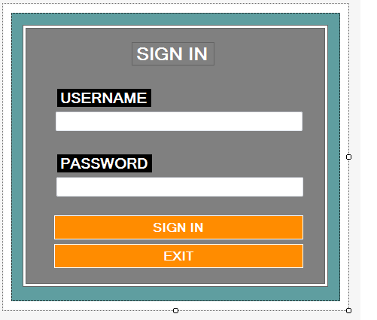

2)Verb – Adverb -Adjective

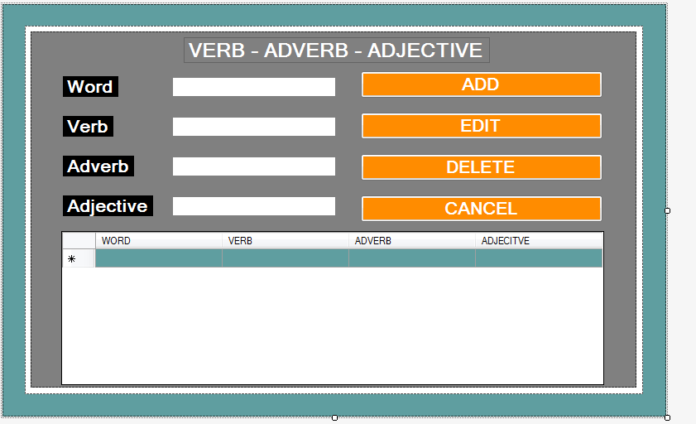

3) Userdashboard

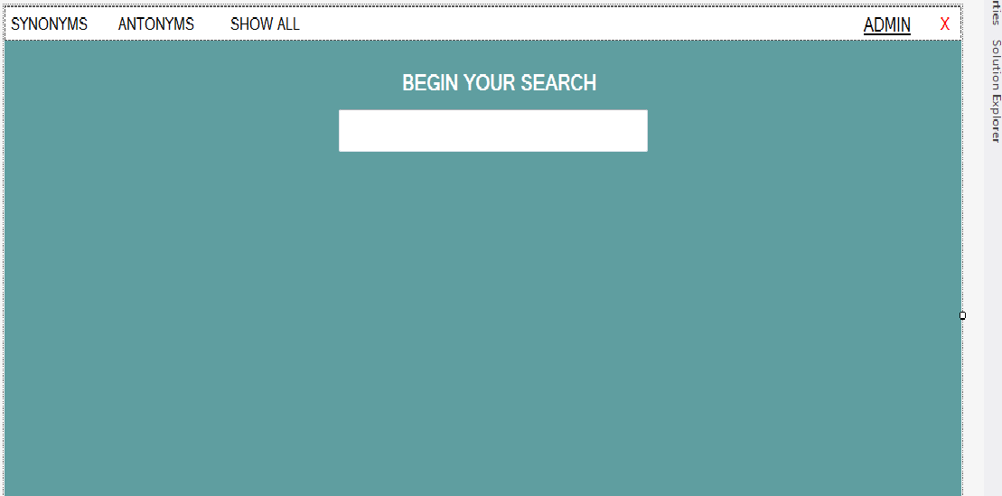

4)Synonyms

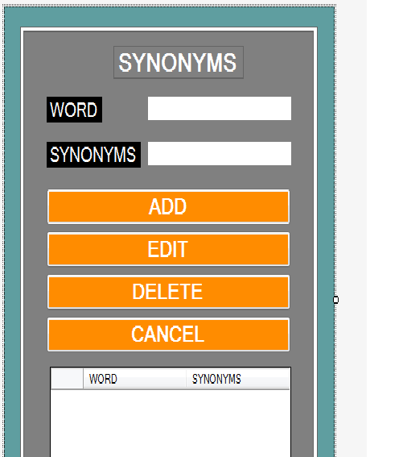

5)Add New Word

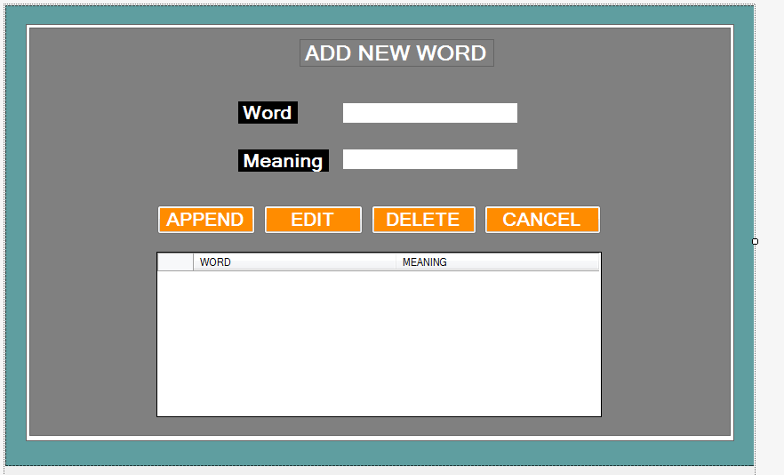

6) Admindashboard

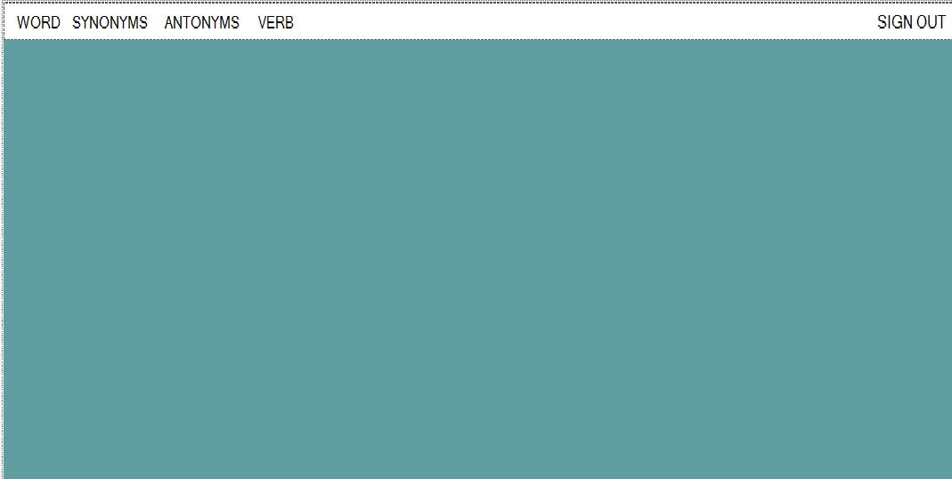

7)Antonyms

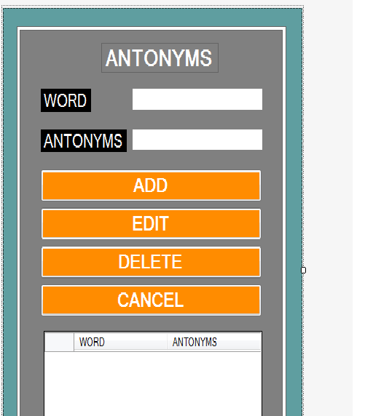

**[7]. Limitation & Future Enhancement**

Limitation

* It’s not work on WAN network.
* Some Validation – I can’t give Some fildes validation because of the time limit.
* Some Buges in application – I can’t fix bug because of the time limit.

Future Enhancement

* Making the UI more user friendly.
* Multilanguage Support.
* Developing the android app for accessing application in stan alone way.

**[8]. BIBLIOGRAPHY**

The bibliography contains references to all the documents that were used to develop the application.

# Books

A)Programming with C#.NET

B) Oxford Dictionary

# Web Sites

* + - [**www.stackoverflow.com**](http://www.stackoverflow.com/)
    - **www.c#corner.com**
    - [**www.tutorialspoint.com**](http://www.tutorialspoint.com/)